PLUGGING INTO THE FUTURE:
An Exploration of Electricity Consumption Patterns

Table of Contents
Table of Contents 2
1. INTRODUCTION 3
1.1 Project Overview 3
1.2 Purpose 3
2. IDEATION PHASE 3
2.1 Problem Statement 3
2.2 Empathy Map Canvas 3
2.3 Brainstorming 3
3. REQUIREMENT ANALYSIS 3
3.1 Customer Journey Map 3
3.2 Solution Requirement 4
3.3 Data Flow Diagram 4
3.4 Technology Stack 4
4. PROJECT DESIGN 4
4.1 Problem – Solution Fit 4
4.2 Proposed Solution 5
4.3 Solution Architecture 5
5. PROJECT PLANNING & SCHEDULING 5
5.1 Project Planning 5
6. FUNCTIONAL AND PERFORMANCE TESTING 5
6.1 Performance Testing 5
7. RESULTS 6
7.1 Output Screenshots 6
8. ADVANTAGES & DISADVANTAGES 6
9. CONCLUSION 6
10. FUTURE SCOPE 6
11. APPENDIX 6
Source Code (if any) 6
Dataset Link 6
GitHub & Project Demo Link 7

1. INTRODUCTION

1.1 Project Overview
This project analyses electricity consumption across different states and regions of India by building an end-to-end data pipeline. Raw consumption data is pre-processed and queried using Microsoft SQL Server, analysed and visualized using Tableau, and made accessible to end users through a web application built with Flask. The project moves from raw, unstructured data to clear, interactive, and web-accessible insights.

1.2 Purpose
The purpose of this project is to uncover meaningful patterns, trends, and relationships in state-wise and region-wise electricity consumption in India. These insights can support better energy planning, highlight regional disparities in consumption, and provide a foundation for data-driven decision-making by planners, researchers, or utility providers.

2. IDEATION PHASE

2.1 Problem Statement
Electricity consumption data across Indian states is often scattered, inconsistent, and difficult to interpret in raw form. Stakeholders lack an easy way to compare consumption across regions, identify seasonal or long-term trends, and access these insights conveniently without specialized software. There is a need for a structured pipeline that cleans this data, visualizes it meaningfully, and makes it accessible through the web.

2.2 Empathy Map Canvas
Persona Element | Description
Says | “I need to understand where and why electricity consumption is high, but the raw data is too scattered to make sense of.”
Thinks | “If I could see clear trends across states, I could plan resources and policies more effectively.”
Does | Manually checks disconnected reports and spread sheets; struggles to compare states/regions consistently.
Feels | Frustrated by fragmented data and the lack of a single, visual, easy-to-interpret source of truth.

2.3 Brainstorming
- Build a centralized database to store and clean electricity consumption records (Microsoft SQL Server).
- Use SQL queries to aggregate data by state, region, and time period.
- Create interactive dashboards to visually compare consumption trends (Tableau).
- Develop a lightweight web application to present the dashboards/insights (Flask).
- Ensure the solution is modular so each stage (data, visualization, web) can be updated independently.

3. REQUIREMENT ANALYSIS

3.1 Customer Journey Map
Stage | User Experience
Awareness | User recognizes the need to understand state-wise electricity consumption.
Data Access | Raw consumption dataset is collected and made available for processing.
Pre-processing | Data is cleaned and structured in Microsoft SQL Server.
Exploration | User explores trends and comparisons through Tableau dashboards.
Access via Web | User accesses the dashboards/insights conveniently through the Flask web application.
Decision-Making | User draws conclusions and uses insights for planning or reporting.

3.2 Solution Requirement
- Functional: Import, clean, and query raw electricity consumption data in SQL Server.
- Functional: Generate state-wise, region-wise, and time-based aggregated views.
- Functional: Build interactive Tableau dashboards connected to the processed data.
- Functional: Serve the dashboards/insights through a Flask web application.
- Non-functional: The system should be accurate, easy to navigate, and reasonably fast to load.
- Non-functional: The pipeline should be maintainable and extensible for future datasets.

3.3 Data Flow Diagram
Raw Dataset → Microsoft SQL Server (Cleaning, Transformation, Querying) → Processed/Aggregated Data → Tableau (Visualization & Dashboards) → Flask Web Application (Presentation Layer) → End User (Browser).
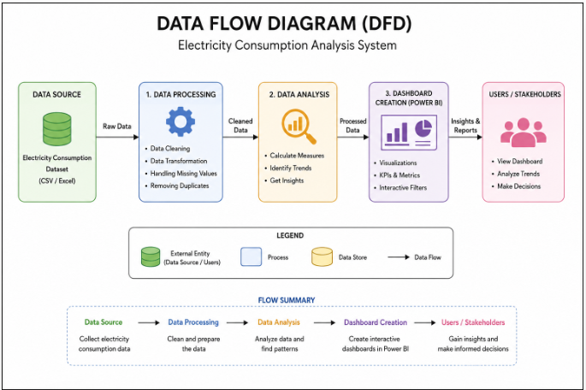

3.4 Technology Stack
Layer / Component | Technology
Database / Data Pre-processing | Microsoft SQL Server
Data Cleaning & Querying | T-SQL (Structured Query Language)
Data Visualization | Tableau
Backend / Web Framework | Flask (Python)
Programming Language | Python, SQL
Frontend (served via Flask) | HTML, CSS, embedded Tableau dashboards
Version Control | Git & GitHub

4. PROJECT DESIGN

4.1 Problem – Solution Fit
The problem of scattered, hard-to-interpret electricity consumption data is addressed by combining structured data pre-processing (SQL Server), insightful visualization (Tableau), and accessible presentation (Flask). This fit ensures that the raw data is not just cleaned but also made understandable and usable by the end user through a simple web interface.

4.2 Proposed Solution
The proposed solution is a three-stage system:
(1) Microsoft SQL Server is used to store and pre-process the raw dataset — handling missing values, standardizing state/region names, and aggregating consumption figures;
(2) Tableau connects to the processed data to build interactive dashboards showing trends, comparisons, and relationships;
(3) a Flask web application hosts and presents these insights, making the analysis accessible through a browser without requiring direct access to SQL Server or Tableau Desktop.

4.3 Solution Architecture
The architecture follows a layered design: a Data Layer (Microsoft SQL Server) for storage and pre-processing, an Analytics/Visualization Layer (Tableau) for building dashboards, and a Presentation Layer (Flask) for web-based access. Each layer communicates in one direction — data flows from the database to the visualization layer, and from there into the web application — keeping the system modular and easy to maintain.
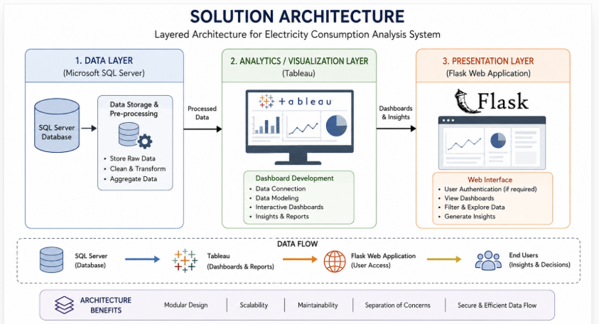

5. PROJECT PLANNING & SCHEDULING

5.1 Project Planning
S.No. | Task | Deliverable | Timeline
1 | Requirement gathering & dataset collection | Finalized dataset | Week 1
2 | Data cleaning & pre-processing in SQL Server | Cleaned, query-ready tables | Week 2
3 | Exploratory analysis & query design | Aggregated views/queries | Week 3
4 | Dashboard design in Tableau | Interactive dashboards | Week 4
5 | Flask web application development | Working web app | Week 5
6 | Integration, testing & refinement | Tested end-to-end system | Week 6
7 | Documentation & final report | Final project report | Week 7

6. FUNCTIONAL AND PERFORMANCE TESTING

6.1 Performance Testing
- SQL queries were tested for correctness against sample subsets of the dataset before running on the full data.
- Aggregation queries (state-wise, region-wise, and time-based) were validated for accuracy against expected totals.
- Tableau dashboards were tested for correct data refresh and responsiveness when filters were applied.
- The Flask web application was tested for successful loading of pages/dashboards and corrects routing.

7. RESULTS

7.1 Output Screenshots

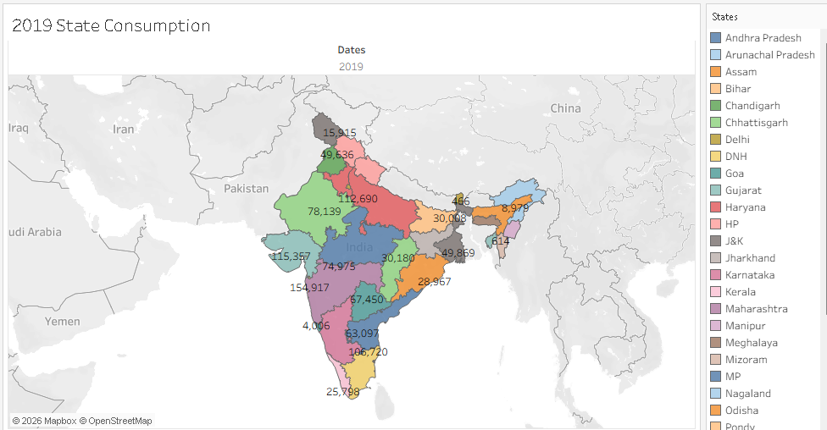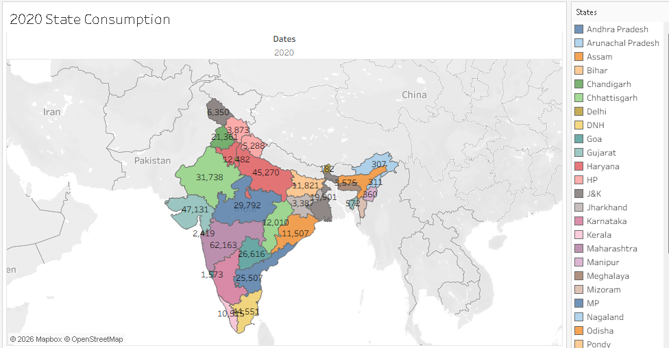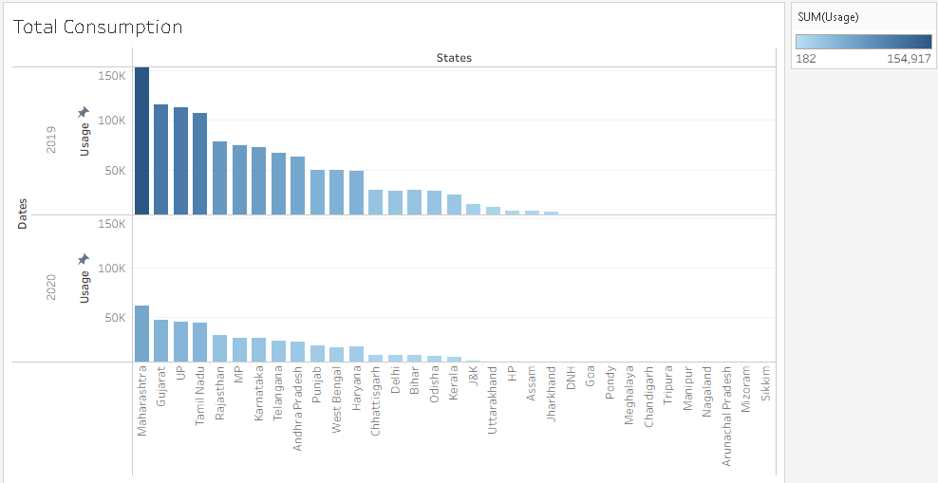

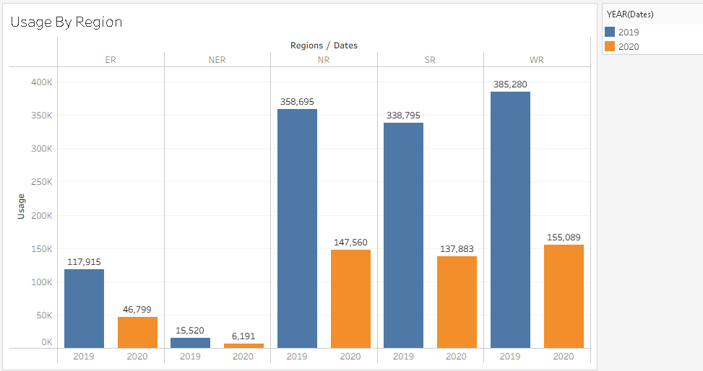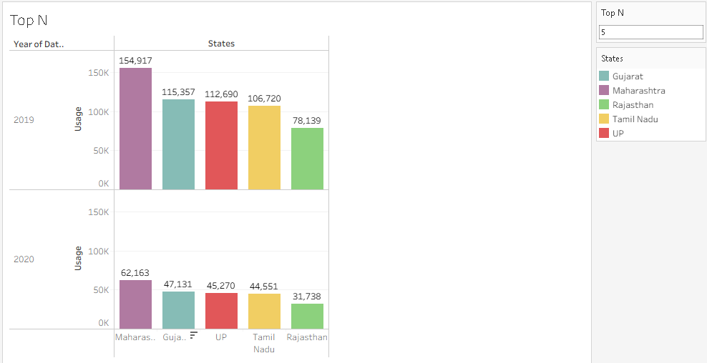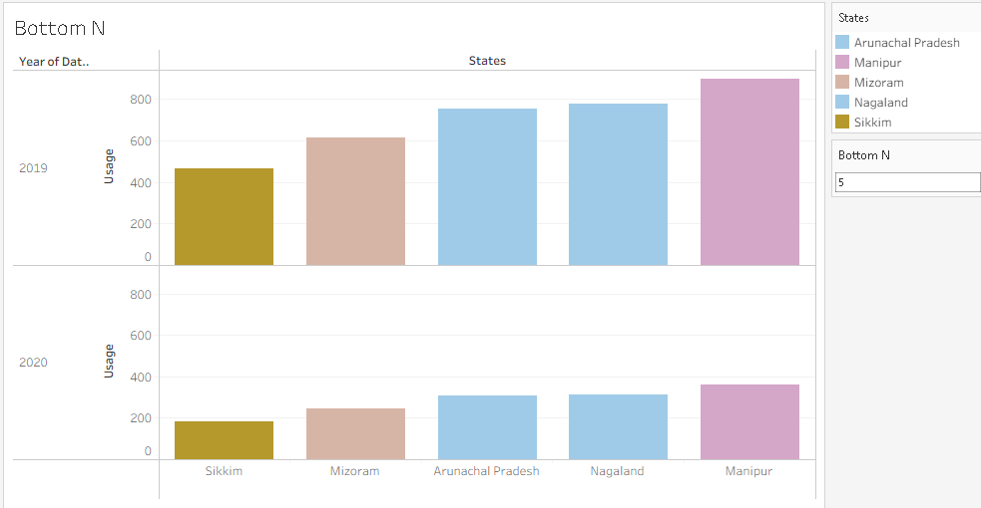

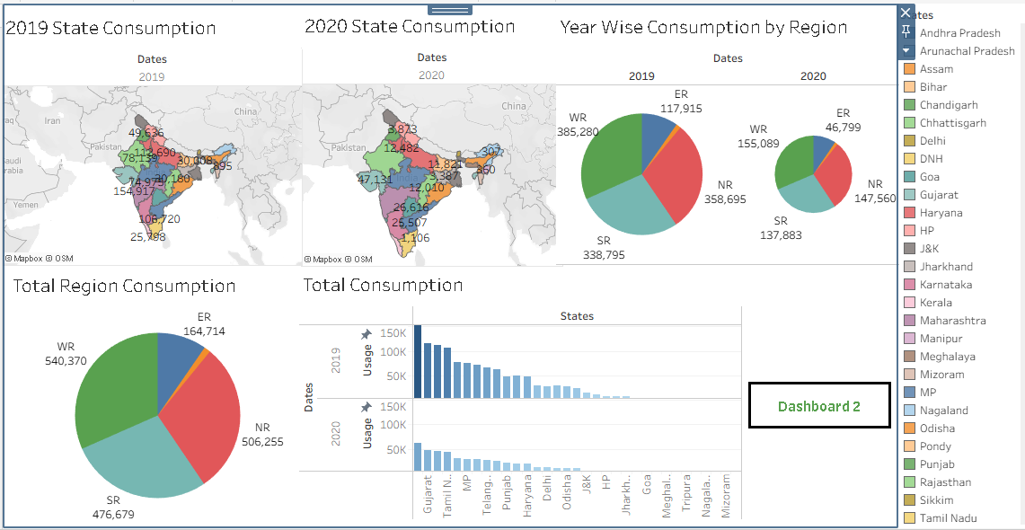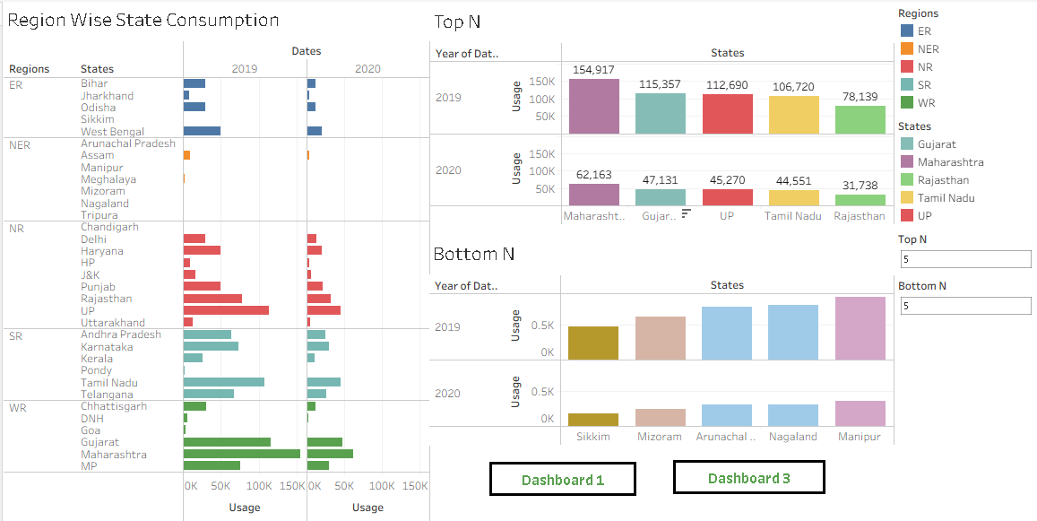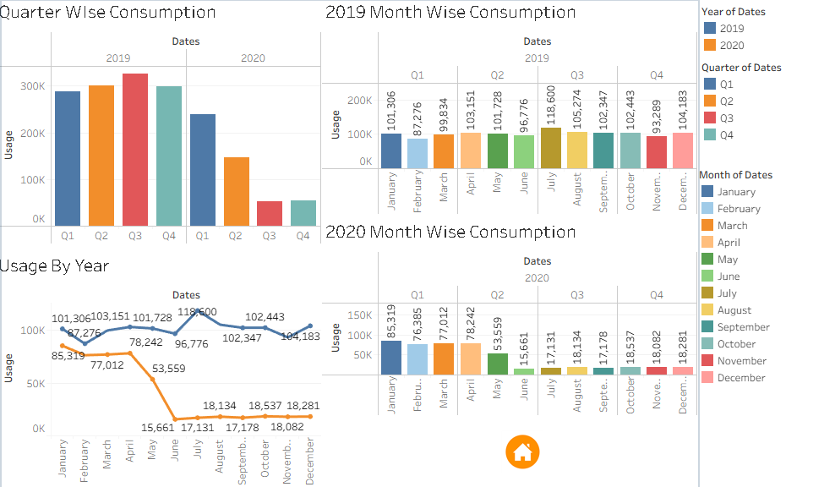

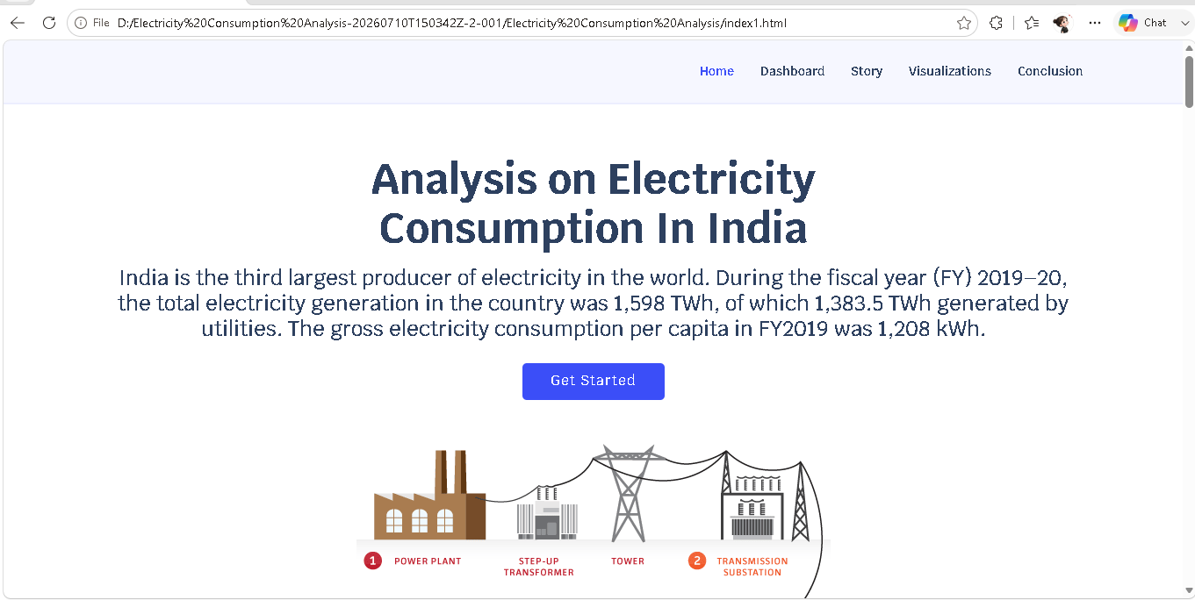

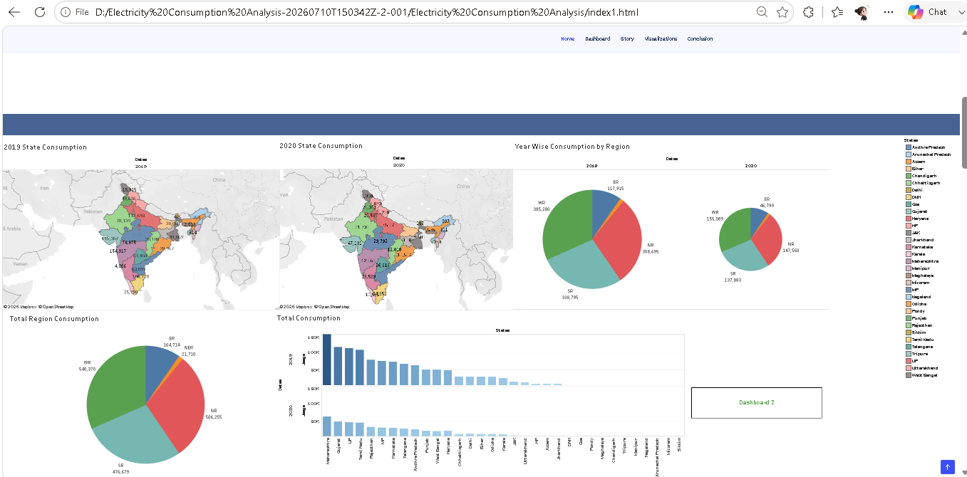

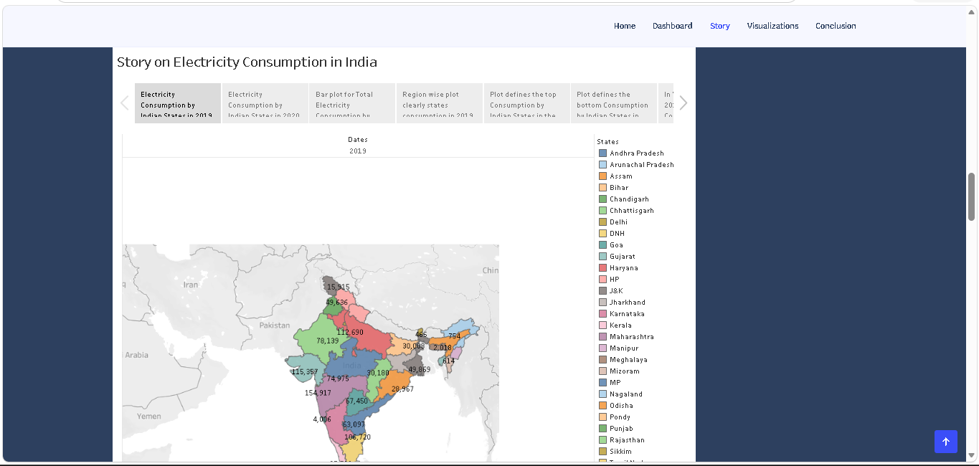

8. ADVANTAGES & DISADVANTAGES
Advantages | Disadvantages / Limitations
Centralizes scattered consumption data into one structured, query-ready source. | Accuracy depends heavily on the quality and completeness of the raw dataset.
Tableau dashboards make trends and comparisons easy to interpret, even for non-technical users. | Tableau visuals embedded in the web app may require Tableau Public/Server access for full interactivity.
Flask integration makes the analysis accessible via a browser, without needing SQL Server or Tableau installed locally. | Currently limited to historical data; does not yet support real-time consumption feeds.
Modular pipeline (SQL Server → Tableau → Flask) makes each stage independently maintainable. | Scaling to very large datasets may require additional performance optimization.

9. CONCLUSION
This project demonstrates a complete, practical workflow for analysing electricity consumption patterns across Indian states and regions — from raw data pre-processing in Microsoft SQL Server, to interactive visualization in Tableau, to accessible web deployment via Flask. The resulting system transforms scattered consumption data into clear, actionable insights that can support better planning and decision-making in the energy sector.

10. FUTURE SCOPE
- Incorporating real-time or near real-time electricity consumption data feeds.
- Extending the analysis to include renewable energy generation and its share of overall consumption.
- Adding predictive modelling/forecasting for future consumption trends.
- Enhancing the Flask web application with user authentication and customizable dashboard views.

11. APPENDIX

Dataset Link

https://drive.google.com/file/d/1JxIkHNwXxjFztKq7ad0_KtkukCqTckNy/view

GitHub & Project Demo Link

https://github.com/chvedasri/ElectricityConsumptions

